Name _______________________________________________ Date ____________________
AP Statistics – Ms. Klimczuk
Chapter 2 Homework – Displaying and Describing Categorical Data
- Young people are more likely than older folk to buy music online. Here are the percents of people in several age groups that bought music online in a recent year.
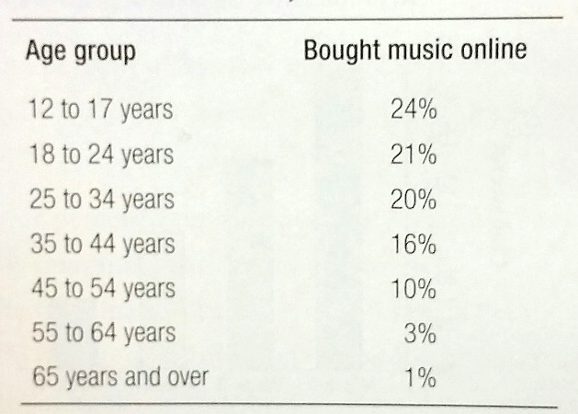

- Explain why it would not be correct to use a pie chart for this data.

- Make a bar graph for your data. Make sure to label your axis.

- Students in a high school statistics class were given data about the main method of transportation to a school for a group of 30 students. They produced the following display:

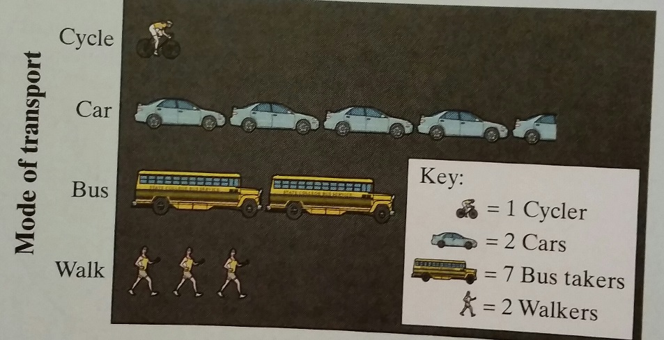

- How is this graph misleading?

- Make a new graph that isn’t misleading. Make sure to label your axis.

- Yellowstone National Park surveyed a random sample of 1526 winter visitors to the park. They asked each person whether they owned, rented, or had never used a snowmobile. Respondents were also asked whether they belonged to an environmental organization. The contingency table summarizes the survey responses.

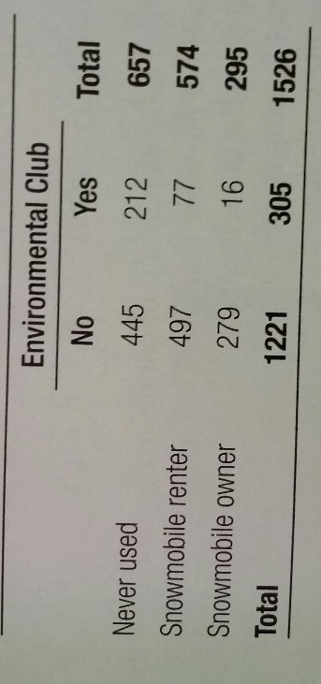

- Do these data suggest that there is an association between environmental club membership and the snowmobile use among visitors to Yellowstone National Park?

- Give appropriate evidence to support your claim. (Hint: Well chosen graphs to display data can help).

- The National Survey of Adolescent Health interviewed several thousand teens (Grades 7 to 12). One question asked was, “What do you think are the chances you will be married in the next 10 years?” Here is a contingency table of the responses by gender.
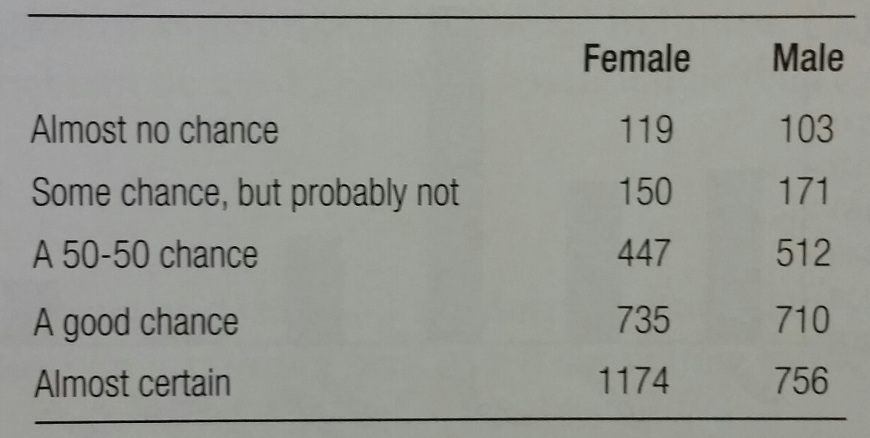

- What was the percent of females among the respondents?

- What percent of males thought they were “Almost certain” to be married in the next ten years?

- What percent of the people who responded “Almost no chance” were male?

- What percent of all respondents thought it was “A good chance” they would get married in the next ten years?

