Name ___________________________________________________ Date ____________________
AP STATISTICS – MS. KLIMCZUK
Chapter 2 Questions (From Notes)
- Observe the frequency table below of Titanic passengers.

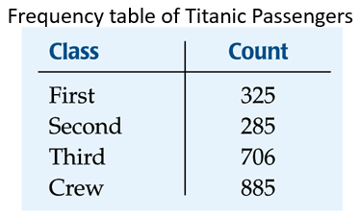
Now make a relative frequency table of the Titanic passengers below:

- You might think that a good way to show the Titanic data is with this display:
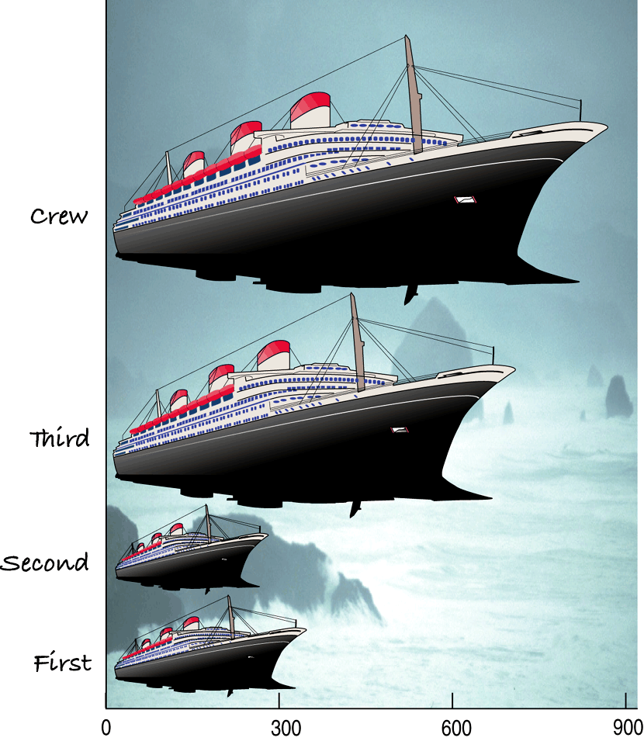
- What is wrong with this?

- This shape display violates the _________________________________________________.
- a) How can we fix the last graphical display?

b) Create a new graphical display that does not violate the area principle.

- Make a relative frequency bar chart of the Titanic Data below:

- When you are interested in parts of a whole, what type of display might you choose? Draw this graphical display below:

- a) What type of table allows us to look at two categorical variables together?

_____________________________________________________
Example: We can examine the class of ticket and whether a person survived the Titanic:
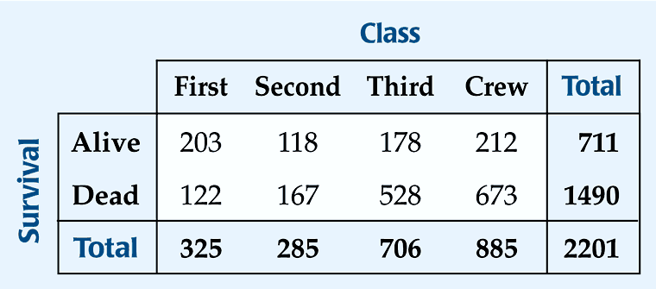
b) The margins of the table, both on the right and on the bottom, give totals and the frequency distributions for each of the variables. These are called:
______________________________________________________
c) What is the marginal distribution of survival?

d) Each cell of the table gives the count for a combination of values of the two values. For example,
what does the second cell in the crew column tells us?

- A conditional distribution shows the distribution of one variable for just the individuals who satisfy some condition on another variable.

The following is the conditional distribution of ticket Class, conditional on having survived:

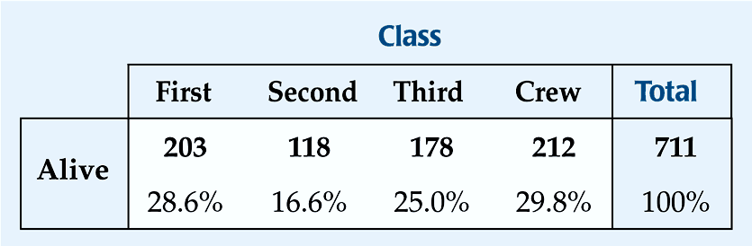

Now, create the conditional distribution of ticket Class, conditional on having perished:

- Now you can make two pie charts for the two distributions.

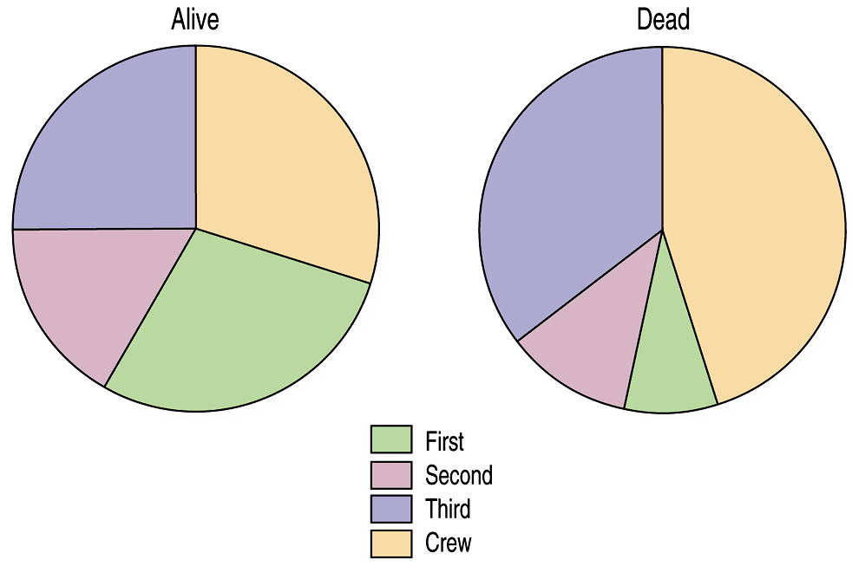

- Is the distribution of Class for the survivors different from that of the non-survivors? Explain.

- Do you think that Class and Survival are associated? Explain.

- So is Class and Survival independent of each other? Why or why not?

Independence: The variables are considered independent when the distribution of one variable in a contingency table is the same for all categories of the other variable.
- a) What other type of graphical display uses parts of a whole?

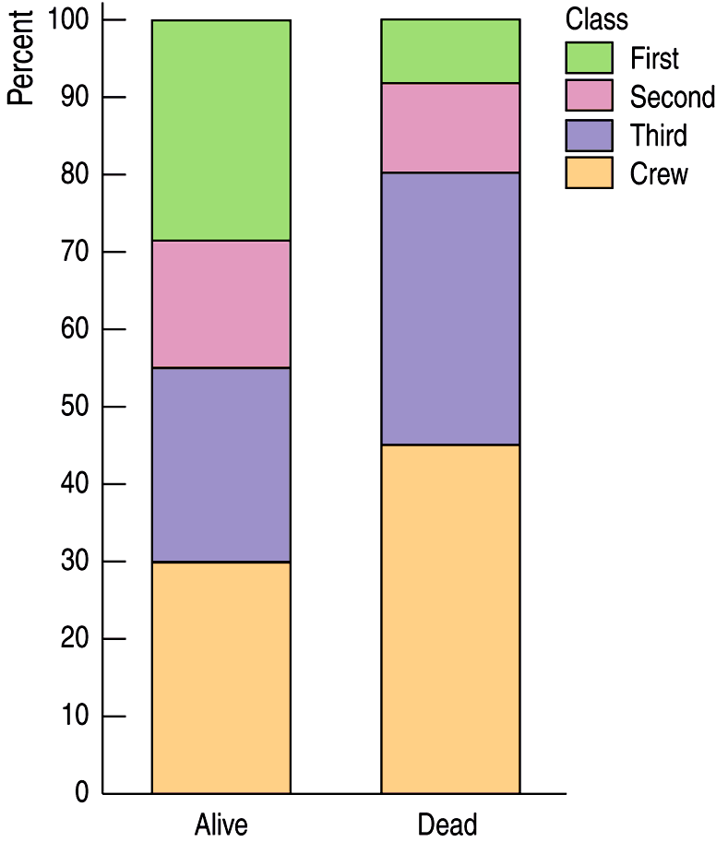

How is this type of display similar to a pie chart?

How is it different from a pie chart?

