Name ___________________________________________________ Date ____________________
AP STATISTICS – MS. KLIMCZUK
Chapter 9 Questions (From Notes)
- When can we use a linear model?

- How can we straighten bent relationships?

- Here is the scatterplot for fuel efficiency (in miles per gallon) vs weight (in pounds) for cars.
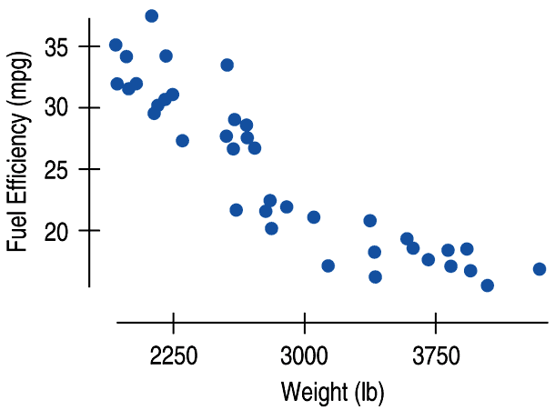
Describe this graph.

- Here is the residuals plot for the scatterplot for fuel efficiency (in miles per gallon) vs weight (in pounds) for cars.
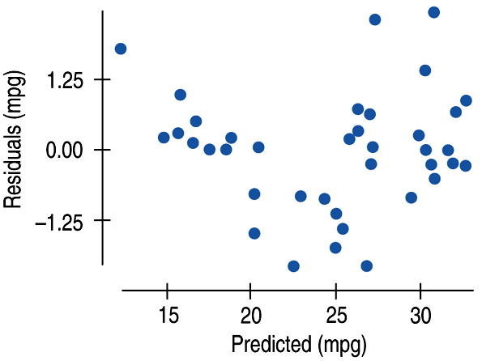
Would you still say that the relationship is linear? Why or why not?
- Now think about the regression line through the points on the original scatter plot.

- How much do you think a car would have to weigh to have a fuel efficiency of 0 mpg?

- Do you think this is accurate?

- A Hummer H2 weighs about 6400 pounds. Based on your prediction above, what do you notice?

- One way to re-express data is to take the reciprocal. What would be the reciprocal for miles per gallon?

- We can re-express fuel efficiency as gallons per hundred miles (a reciprocal).
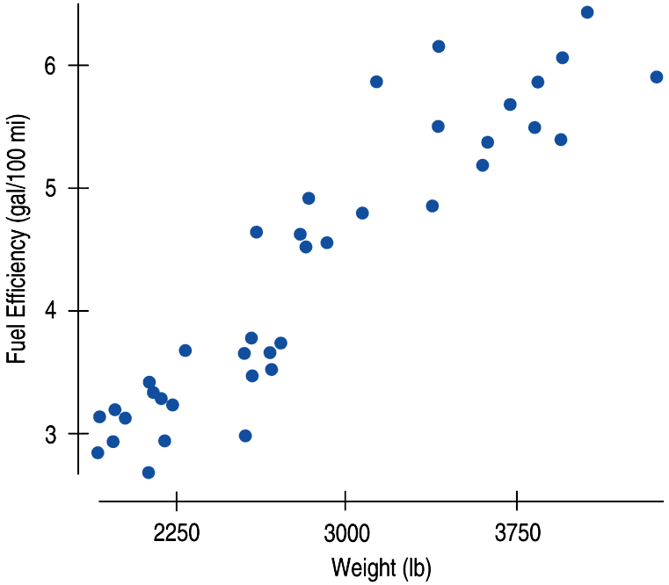
Describe this graph. What do you notice?

- Here is residuals plot for the fuel efficiency as gallons per hundred miles.

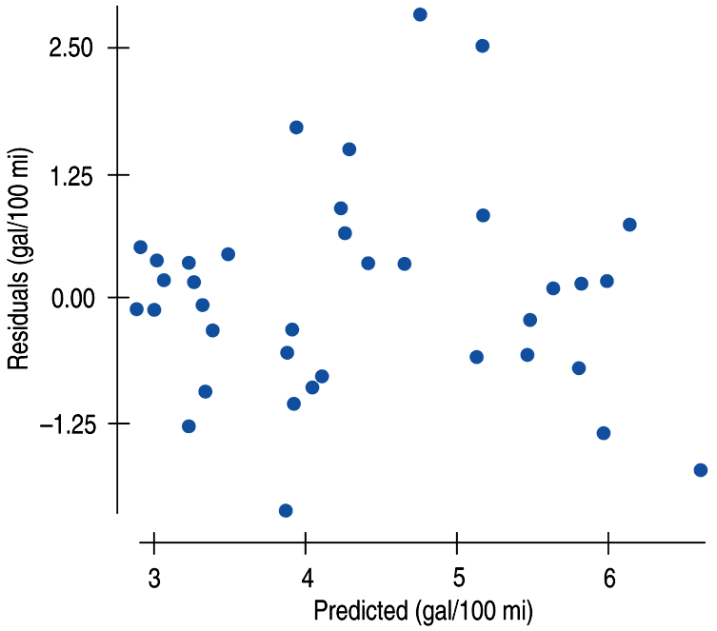
What does the residuals plot tell you about the appropriateness of using a linear model?

- Now compare the two scatter plots.

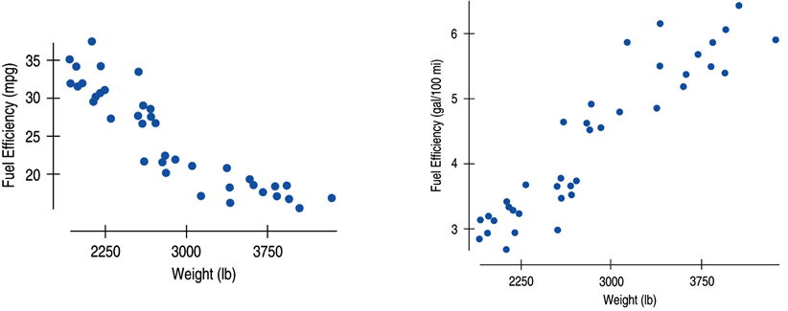

The direction of the association is positive now. Why?

- a) What does the reciprocal model tell us about the Hummer? (weight is 6400 pounds)

b) What does this mean?

c) How many miles per gallon would this be?

d) Is this a much more reasonable prediction than earlier? Why?

- a) Why would you want to re-express this data?
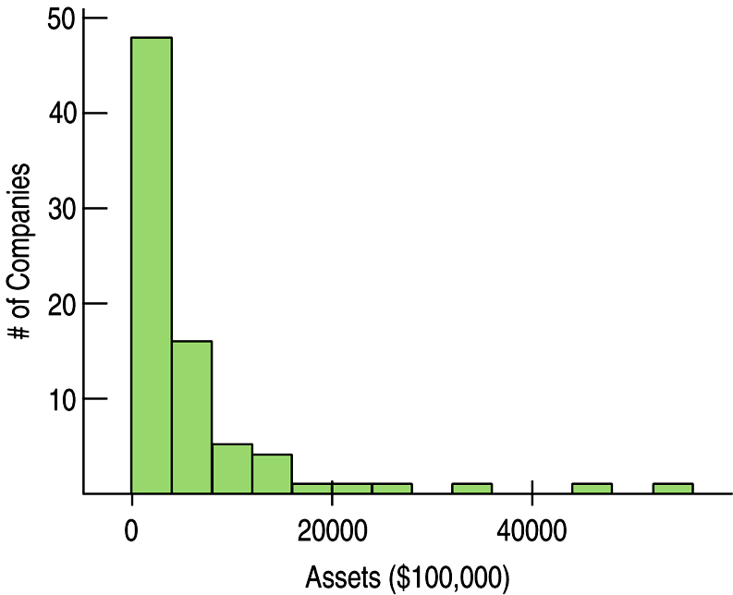
- How did we re-express the graph here? How is this better?
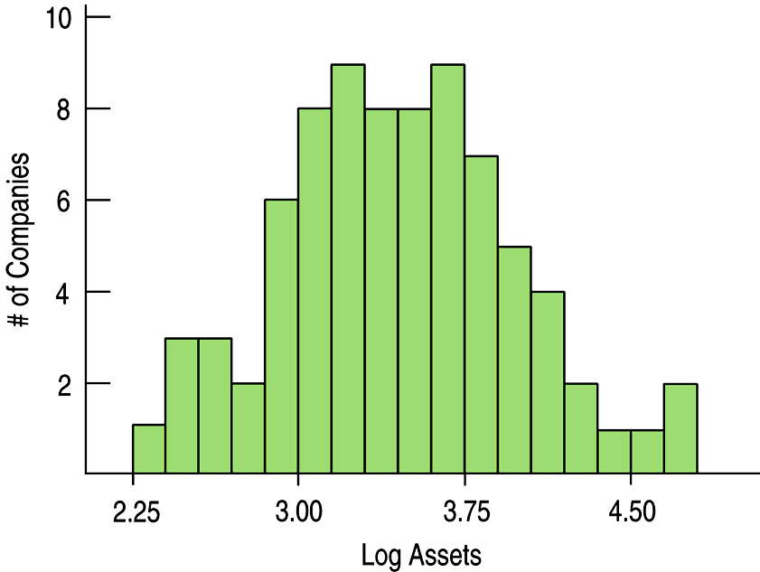
- a) Why would you want to re-express this data?

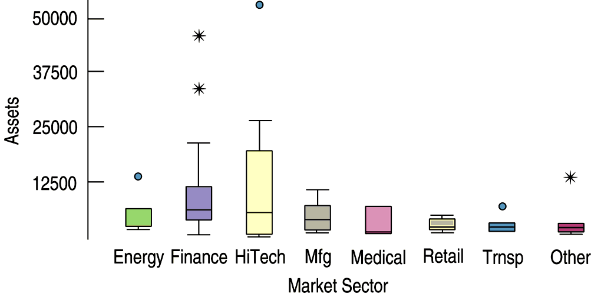

- How did we re-express the graph here? How is this better?

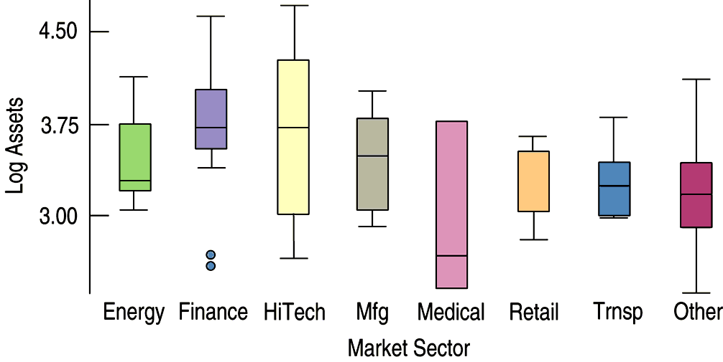

- a) Why would you want to re-express this data?

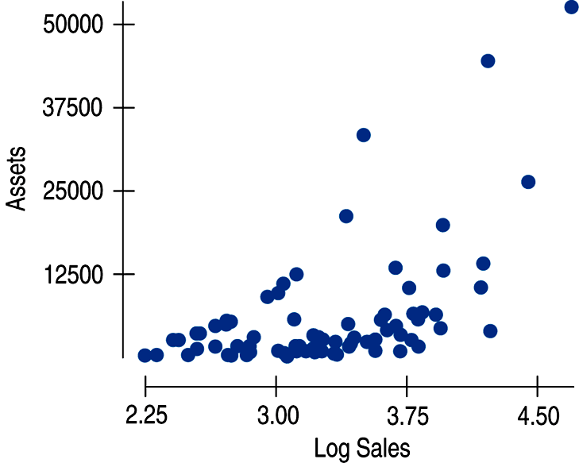

- How did we re-express the graph here? How is this better?

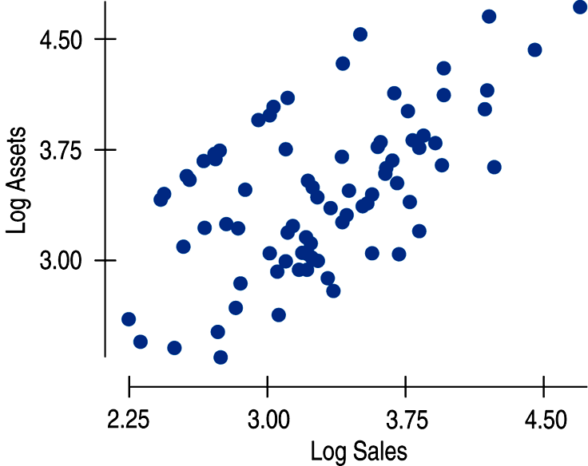

- a) Why would you want to re-express this data?
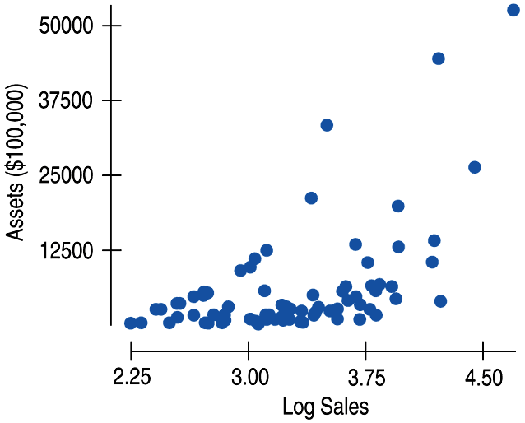
b) How did we re-express the graph here? How is this better?
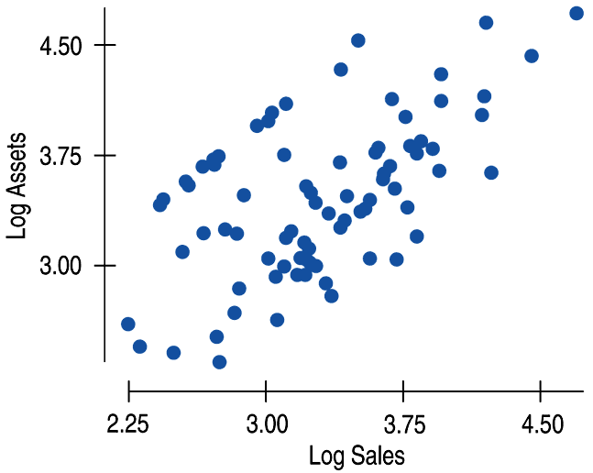

- What feature of each of these displays suggest that a re-expression may be helpful?

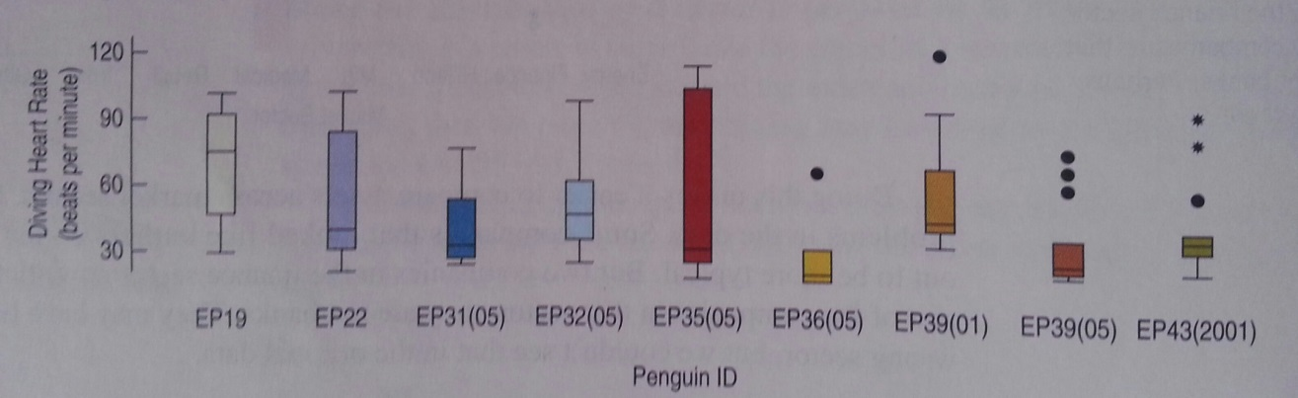

b) c) 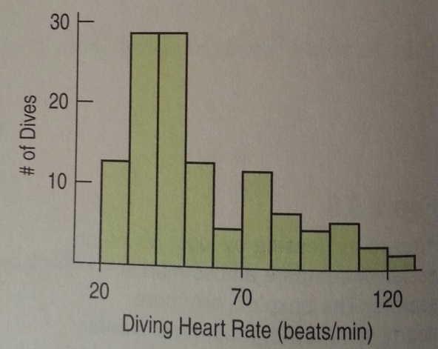 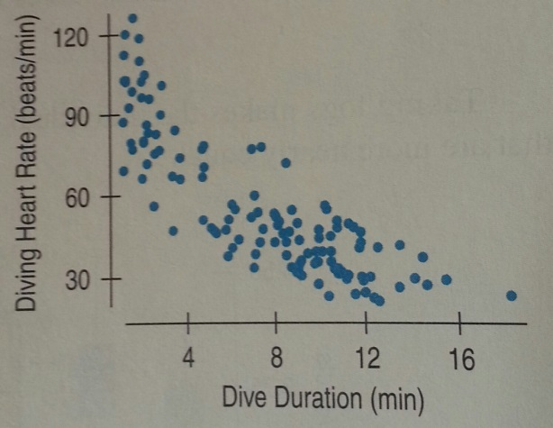
16. What is the Ladder of Powers?

Write solutions to Just Checking Box on Pg 237 here:

- Back to these Graphs:
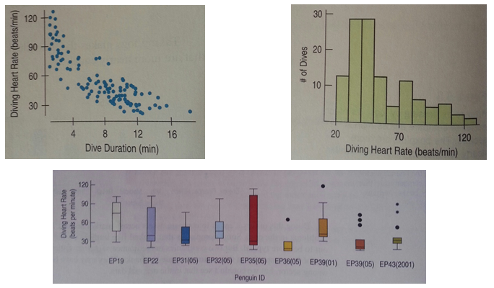
- Let’s start the process of re-expressing. Where would you start on the Ladder of Powers and why?

- Heart rate is in beats/minute. Let’s try taking the negative reciprocal re-expression and use minutes/beat. Now look at the re-expressed data below:
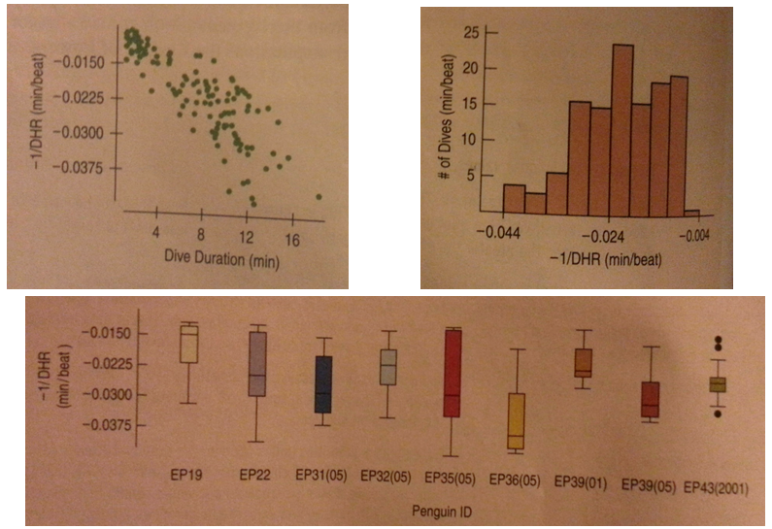
Write a description about each of the graphs.

- Did the re-expression work the way we wanted it to? Why or why not? How might we fix this?

- Overall, it looks like it may have moved a bit too far. If this happens, try a re-expression that is lower on the ladder. Now, let’s try something halfway between 1 and -1, like the logarithm. Look at the re-expressed data below:
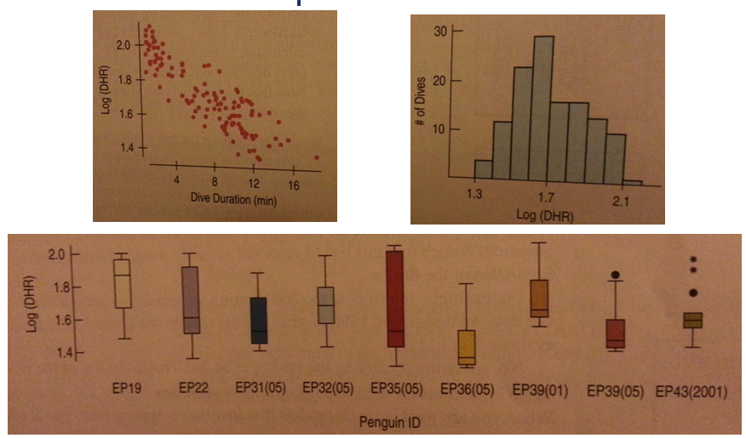

Write a description about each of the graphs.

- Did the re-expression work the way we wanted it to? Why or why not?

- What if we use the ladder of powers and we are not happy with our residuals plot? What can we do?

This can help you…

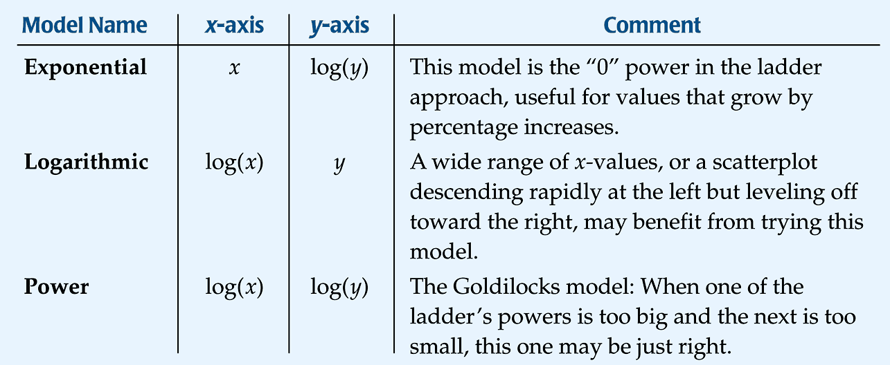

- If there’s a curve in the scatterplot, why not just fit a curve to the data (as shown below)?

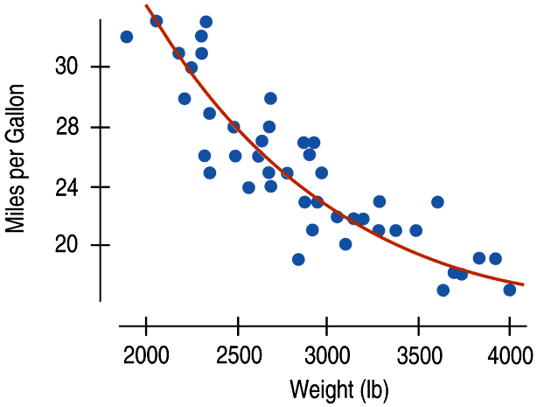
- Why is it more beneficial to fit lines to your data?

