Name _________________

**Distributions: Graph & Describe**

1. There are two kinds of data:

* _______________ data (like flavors of ice cream)
* _______________ data (like times to run a mile)

1. There are many kinds of graphs, but

* A histogram displays _______________ data.
* A bar graph displays _______________ data.



1. Histograms and bar graphs display DISTRIBUTIONS.

* A distribution gives all possible values on the ___-axis.
* A distribution gives their frequency on the __-axis.
  + The frequency can be given as either c_______ or p_____________.

1. How do you describe a distribution from a graph?

* Histograms: C ____________. U ____________. S ____________. S ____________.
* Bar Graph: ______________________________________________

1. Here’s a graph from the 2013 *Boston Globe.* It displays cosmetologists per 1,000 residents by MA town.

Macintosh HD:Users:shessney:Desktop:2014-09-13:Cosmetologist.PDF

* Cosmetologists per 1,000 residents: What kind of data is this? ______________
* What type of graph displays this kind of data? _________________
* Does this graph display a distribution? ____

Explain. ________________________________________________________________________

* What kind of graph is this? ______________
* Use this graph to make a histogram. (Hint: What are the possible values for number of cosmetologist per 1,000 residents and what is their frequency?)
* Describe the distribution of cosmetologists by MA town.

Here’s a Question 6 that too many students got wrong. Given what you now know about distributions and their graphs, I bet you can correctly answer the questions below.

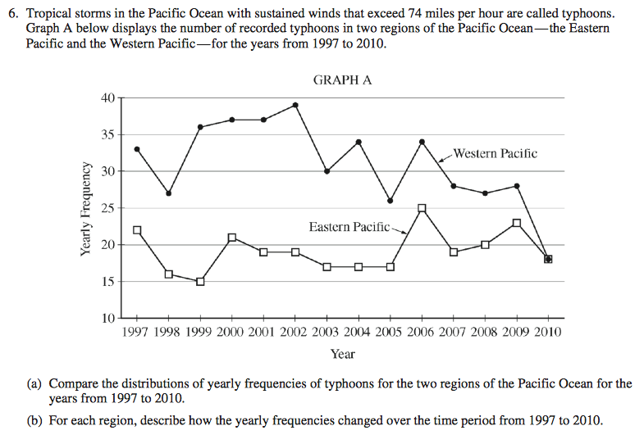

Hint: Remember how a histogram displays a distribution. Create a histogram. What x-axis bin widths would be very use to use? Then, use the histogram to describe the distribution.

