The distribution of heart disease death rates, per 100,000 people, in 19 Western countries is close to this normal distribution.

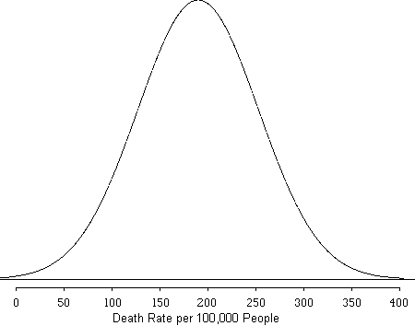
1. Approximate the mean heart disease death rate per 100,000?

2. Approximate standard deviation of the heart disease rate per 100,000 people?

3. Calculate the z-score for a country with a death rate of 260 per 100,000?

4. Calculate the z-score for a country with a death rate of 50 per 100,000?

