Name _____________________________________________________ Date _________________
Intro to Statistics – Ms. Klimczuk
MEASURING SHAPE AND CENTER WORKSHEET
Directions: For each set of data, write down the following:
- Whether the distribution is uniform, unimodal, or bimodal
- Whether the distribution is symmetric or skewed
- The mode
- The max, min, and range
- Outliers
- The median, 1st quartile, 3rd quartile, and the interquartile range (IQR)
- The mean
- State whether the mean or the median would best describe the center of the distribution. Why?

Problem 1:
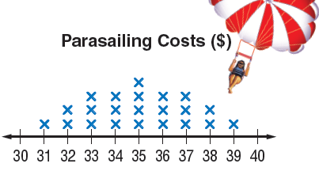
a)

b)

c)

d)

e)

f)

g)

h)
Problem 2:
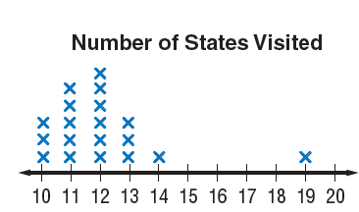
a)

b)

c)

d)

e)

f)

g)

h)

